

|  |
| --- |
| [Version 2.2]  **Last saved by: Ben McGregor**  **Last saved on:** 29/03/2015 |

|  |
| --- |
| Web-based application design |
| 29/09/2014 |
| **Ben McGregor**  CO600: JustHealth Supervisor: Yang He |

Contents

1.0 Overview 2

2.0 Designs 2

2.1 User log in 2

2.2 Register user 3

2.3 Home screen 3

2.4 Standard page 4

2.5 Account deactivation 5

2.6 Search for a user 6

2.7 View connections 6

2.8 Verify connection 7

2.9 View appointments 7

Add appointment 8

3.0 Post first release re-design 9

3.1 Log in 9

3.2 Registration 10

3.3 Home page (Dashboard style) 10

3.4 Appointments pages 11

3.5 Connections 12

3.6 Settings pages 13

3.7 FAQs 14

3.8 Search 15

3.9 Web notifications 15

Medication and Appointment reminders 16

Dynamic reminders 16

4.0 Patient/Carer correspondence 17

5.0 Admin Portal 18

5.1 Home page 18

5.2 User account settings page 19

5.3 Deactivation settings 19

5.4 Medication settings 20

5.5 Application statistics 20

5.6 JustHealth Twitter 21

# 1.0 Overview

In order to produce a high quality application that fulfils the requirements outlined, it’s important to have designs that give an idea of what an appropriate final result might look like.

The initial designs are likely to be updated throughout the project, especially when developing iteratively within the agile development method. They are primarily created so the appearance and colours are decided on before implementation starts.

This document will include an overview of the initial designs for the web-based application.

# 2.0 Designs

These designs have been produced using mock-up design software, Balsamiq (<https://balsamiq.com/>)

Logo positioning, page headers and footers, colour schemes and fonts will be uniform throughout the pages.

## 2.1 User log in

* The JustHealth logo will stay in the upper-left corner of the screen at all times, with the header of the page based on the colour of the logo background.
* Page backgrounds will all be a shade of light-grey, text fields will be in white with all page content black.
* Buttons will be uniform in size

## 2.2 Register user

* The form fields must be uniform in size and colour, location on the page will be controlled. The page will scroll to show any hidden fields.
* The ‘Register’ button will show at the bottom of the form

## 2.3 Home screen

* Tiles will be colourful and appealing; prioritised and organised on the page
* Tile icons will be centred and clear to the user
* There will be text in the header indicating that the profile belongs to a patient/carer

## 2.4 Standard page

* Quick access icons to be in white to look similar to logo text
* ‘Back’ button to be placed in user friendly location, depending on amount of content.
* Page content to follow QA guidelines.

## 2.5 Account deactivation

* Idea behind deactivation is to make it simple for the user, but attempt to persuade them otherwise
* All fields (excluding comments) on page will be required
* Options for deactivation reason will be the following:
  + I don’t understand how to use JustHealth
  + I’m only leaving temporarily
  + I’m using a different app
  + I receive too many notifications and emails
  + I don’t find JustHealth useful
  + I have privacy concerns
  + Other (Please specify)
* Additional comments will be an optional field
* Users have an option to leave information in the JustHealth database, this is to ease reactivating their account
* Link will show pop up window with reasons for user to leave their data
  + Explain security
  + Explain reactivation process
* When ‘deactivate’ button is pressed, final alert window will be shown to user
* On account deactivation, user will be taken to initial application screen displaying ‘Account deactivation successful’
* Navigation bar on left side to appear on page load
* Settings icon in header has changed to ‘Log out’ button

## 2.6 Search for a user

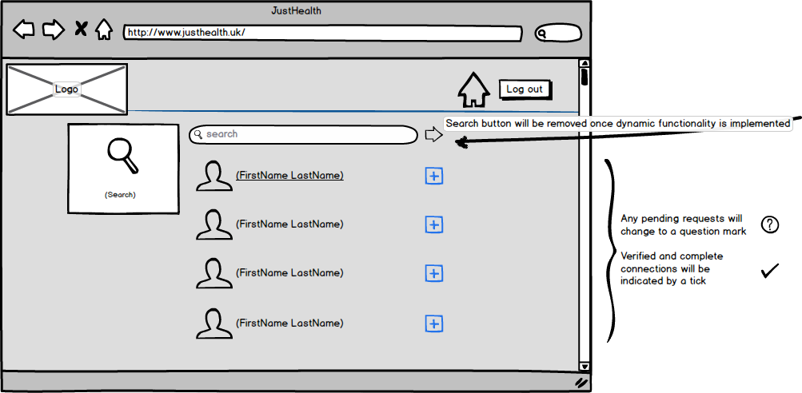

* User will be able to click the search result to view some basic information about the contact

## 2.7 View connections

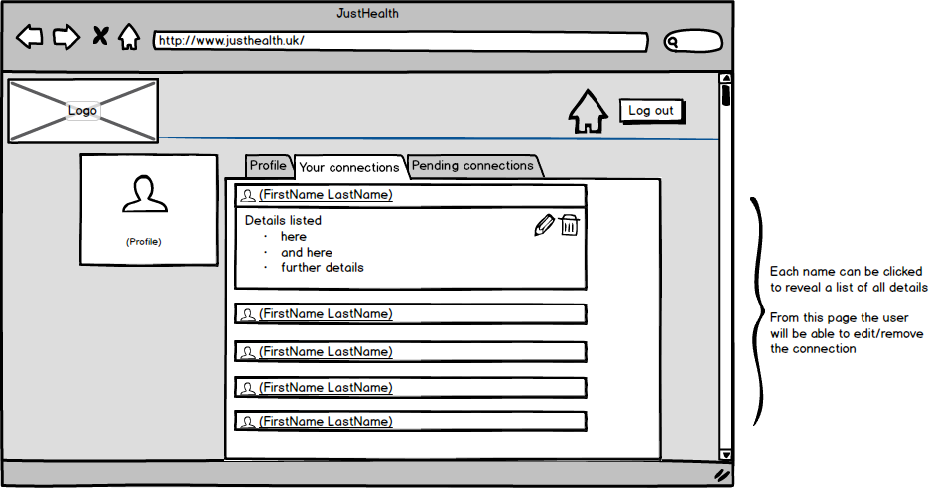

## 2.8 Verify connection

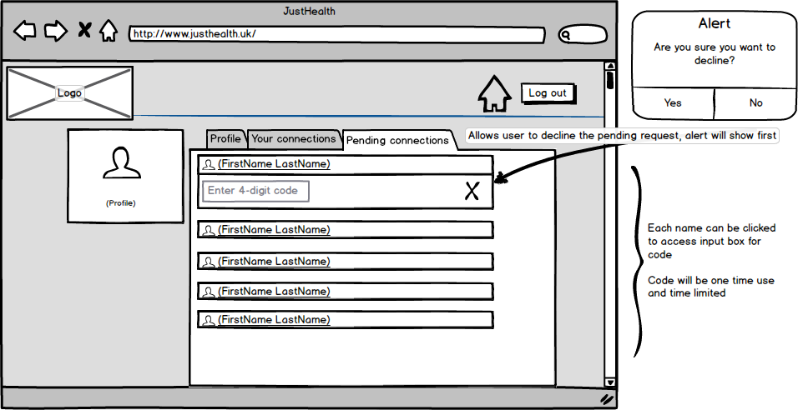

## 2.9 View appointments

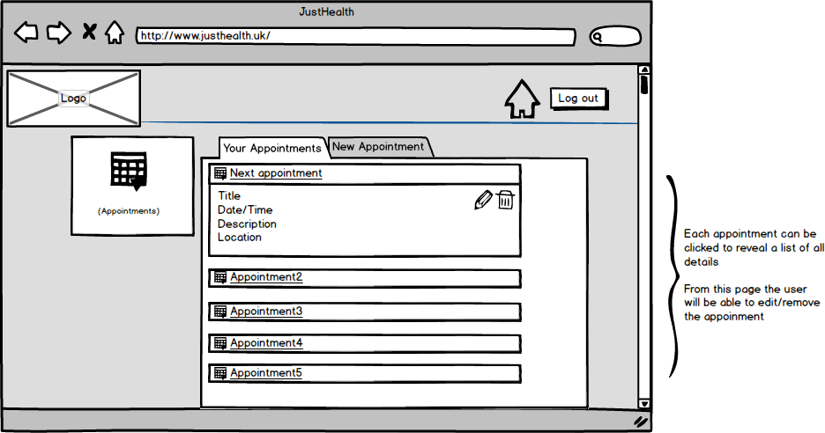

## Add appointment

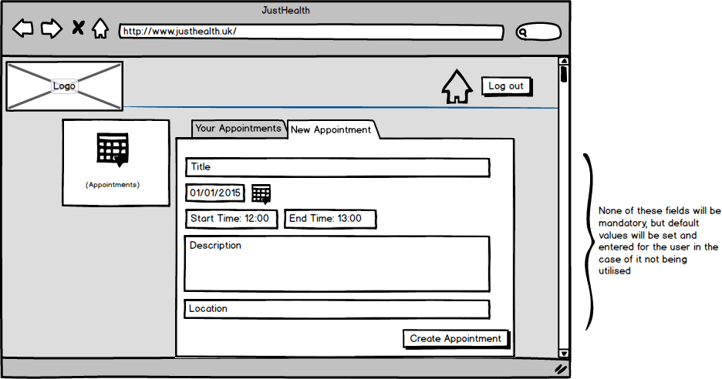

# 3.0 Post first release re-design

As a result of feedback post the first release of JustHealth, we have decided the application is in need of re-design. This is to improve the user interaction with the application and to make it more professional.

Each of the pages have been wire-framed again to give us an idea of the new appearance, this will help us to envision what we are working to produce in regards to design.

## 3.1 Log in

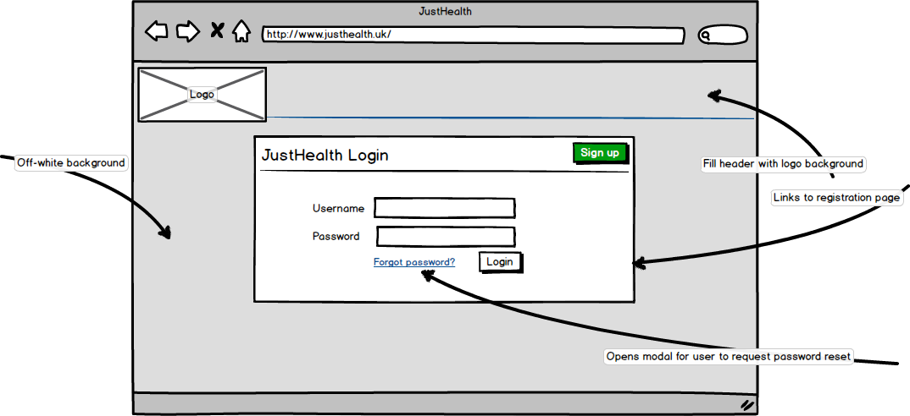

The primary changes to the user log in page are creating a more professional first impression of the application. We will also make navigation to the registration page more obvious to the user.

## 3.2 Registration

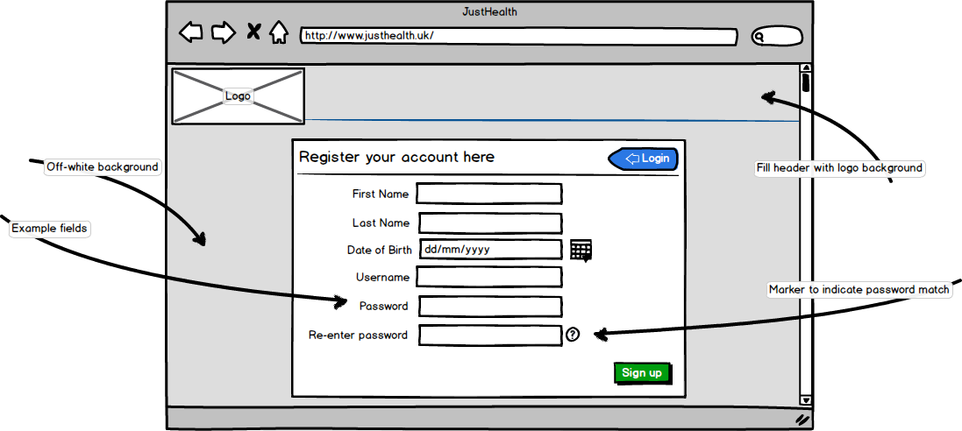

This page is now clearer to the user, some of the feedback we received was that users would not enter data into an application that didn’t look professional, official or of industry standard.

## C:\Users\benmcg92\AppData\Local\Microsoft\Windows\INetCache\Content.Word\webhome2.png3.3 Home page (Dashboard style)

Due to user feedback, we have decided to restructure the navigation of the web application. The tile layout will now be limited to the android application for ease of use, and will be replaced by a dashboard on the web.

The dashboard will incorporate relevant content to the user, depending on account type. From this page, the user will be able to navigate the application easily.

## 3.4 Appointments pages

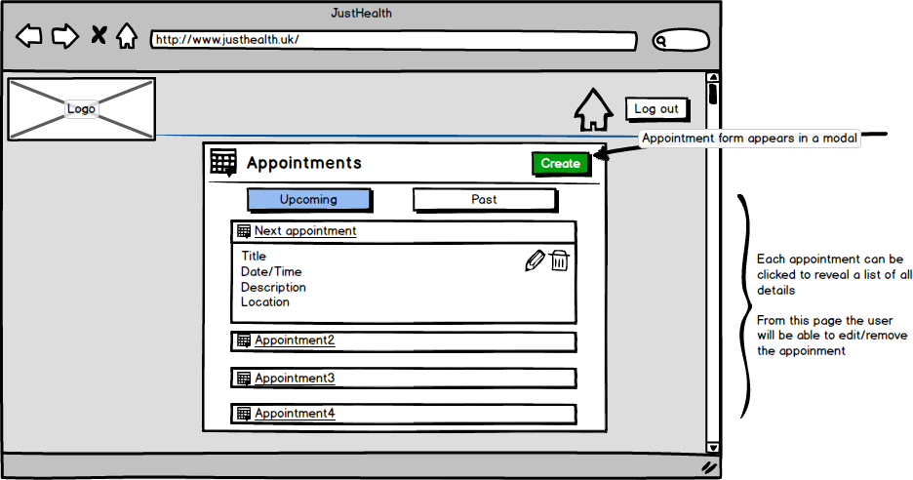

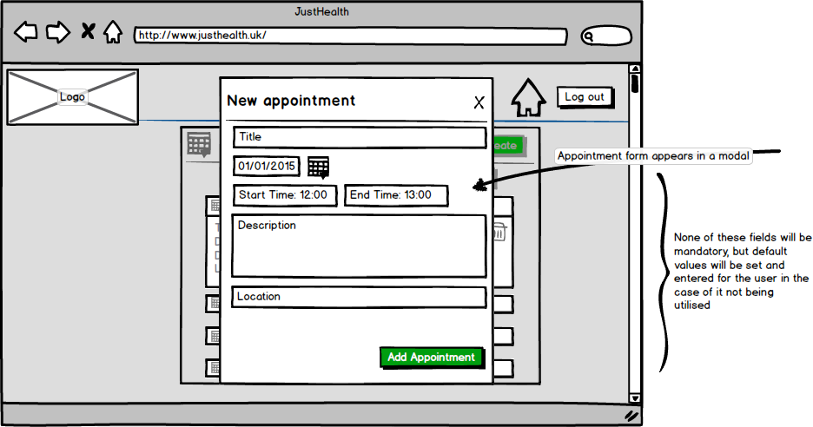Appointments will be reorganised and reordered so the navigation is more user friendly. The main update to this page will be the form to create a new appointment will now open in a modal.

## 3.5 Connections

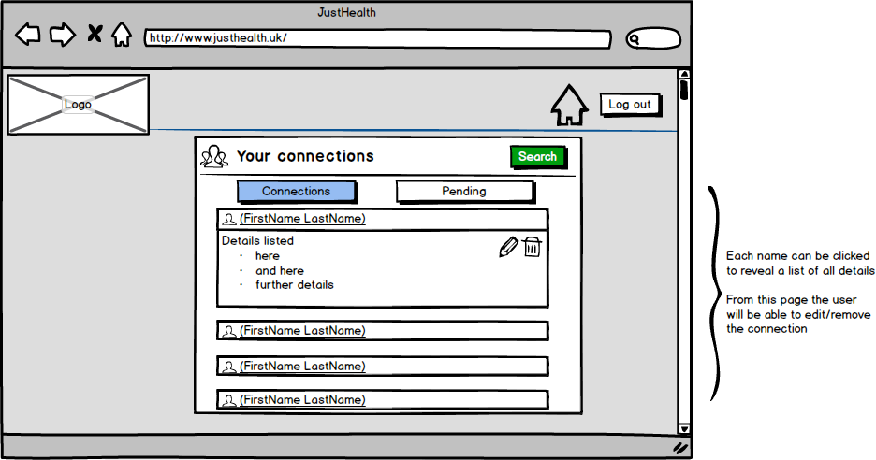

Similarly with connections, the pages are clearer, navigation is simpler and the overall feel is more professional.

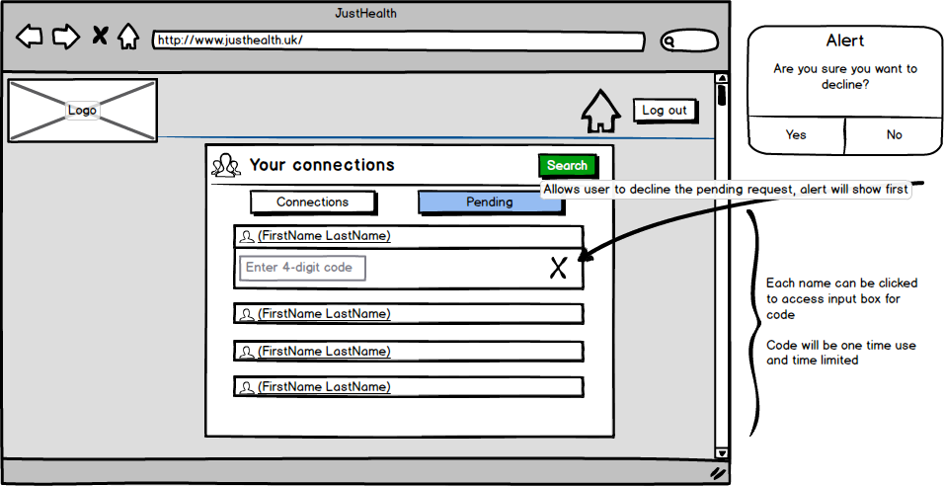

## 3.6 Settings pages

User settings pages will be changed dramatically, the main aims being:

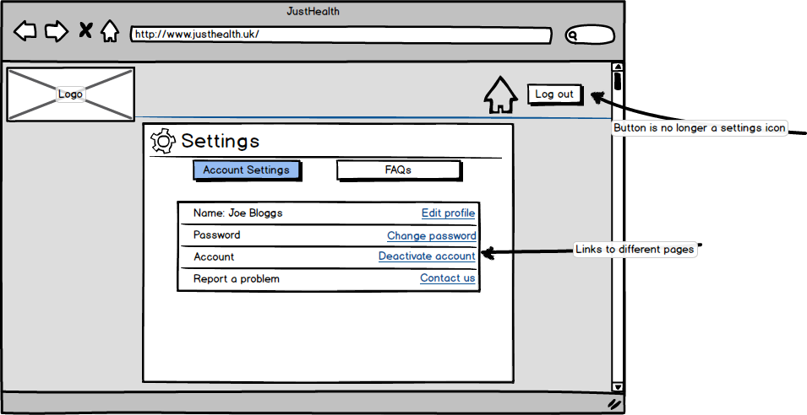

* Keep everything accessible from one location
* Prioritise ease of use
* Give all pages the same appearance

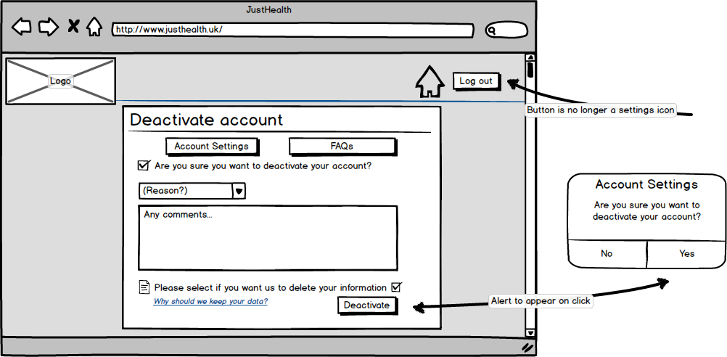

## webfaq23.7 FAQs

Frequently asked questions will now have a dedicated page, this aims to improve user experience. Each question can be clicked to reveal the answer and navigation to different pages will be improved, linking sections where appropriate.

## 3.8 Search

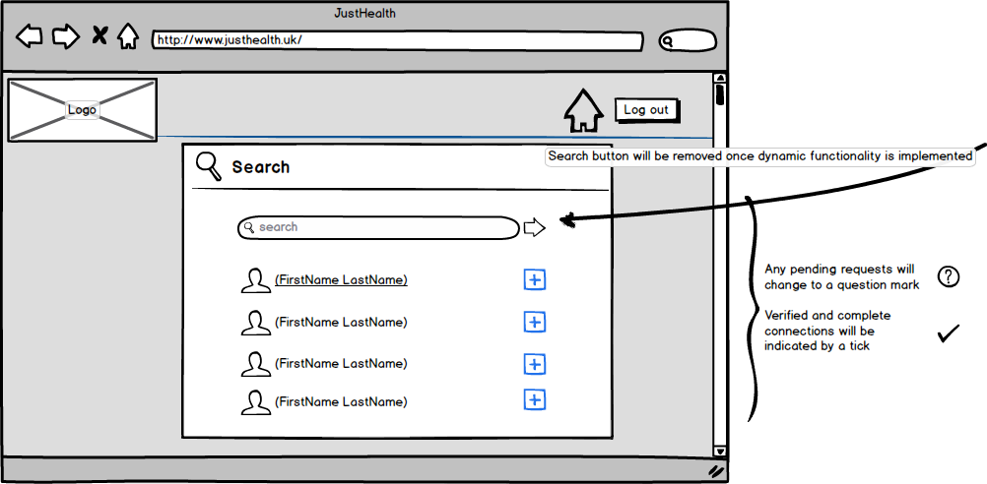

The search page will be improved to give it the same appearance as the other pages. Navigation will also be improved on this page.

## C:\Users\benmcg92\AppData\Local\Microsoft\Windows\INetCache\Content.Word\webnotifications.png3.9 Web notifications

The user will be able to view their new notifications by clicking the icon in the header. If they use the notifications link in the navigation menu, it will take them to a page containing all their notifications. The notifications will be displayed in order (latest at the top)

### C:\Users\benmcg92\AppData\Local\Microsoft\Windows\INetCache\Content.Word\webreminders.pngMedication and Appointment reminders

The user will be shown important notifications and reminders on their dashboard, these will be dismissible, and they can update that they have taken medication from the notification etc.

### Dynamic reminders

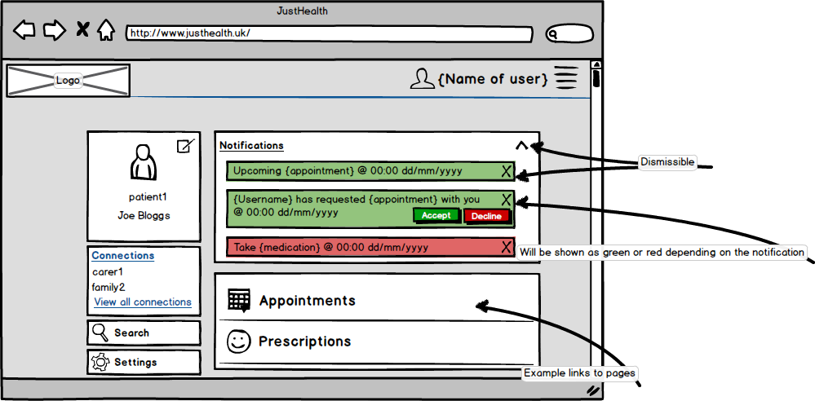The dismissible reminders on the dashboards will become dynamic for certain events, they will have options to either accept or decline requests from connections.

## 4.0 Patient/Carer correspondence

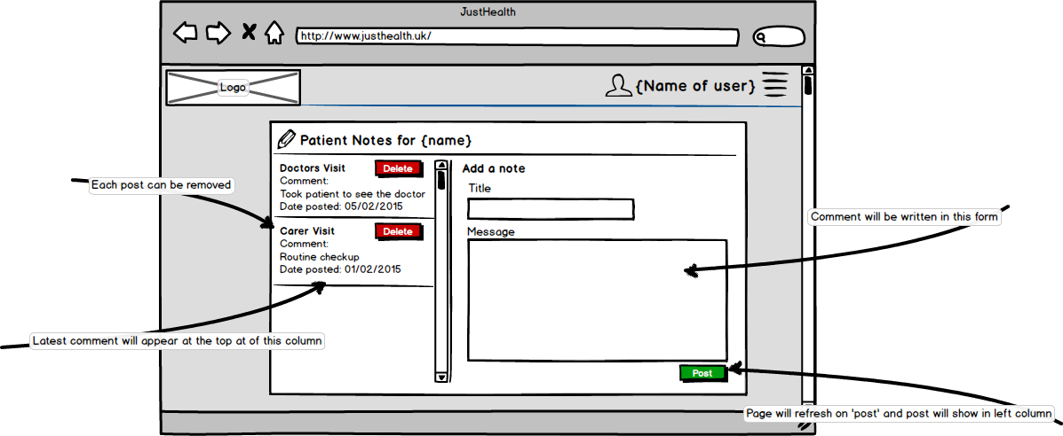Carers will have the option to record notes for their patients, in a further attempt to create a unique application for all needs within the care industry.

# 5.0 Admin Portal

We have decided to add the functionality of an information management portal. It is risky and unsecure to manually control account settings from directly within the database. Below are the designs for an administrative user interface, where they can:

* Edit account settings
* View and add new medication
* View and add new deactivation reasons
* View user statistics
* View JustHealth site statistics

## 5.1 Home page

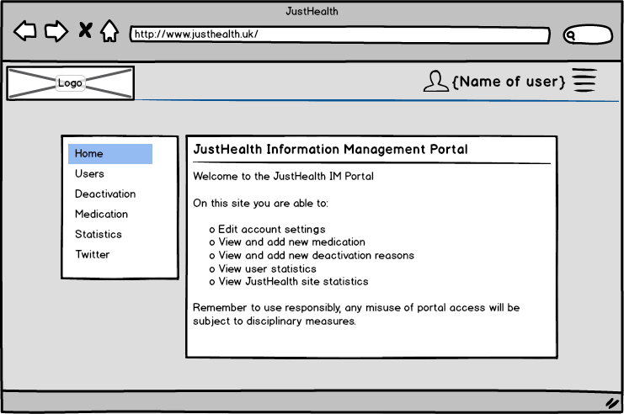

## 5.2 User account settings page

## 5.3 Deactivation settings

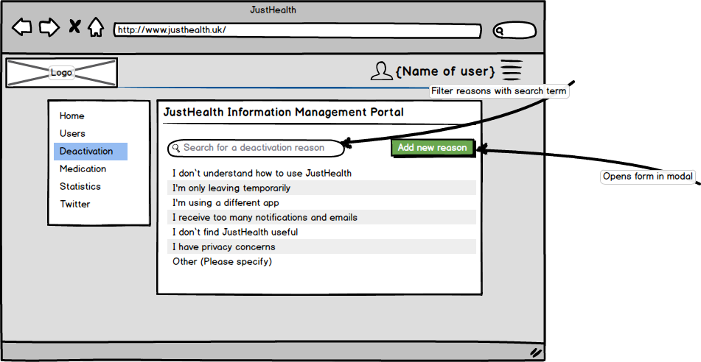This page is not for the admin to deactivate accounts, but rather to change the settings for users to deactivate their own accounts. User accounts can be locked, deactivated or deleted through the user settings page.

## 5.4 Medication settings

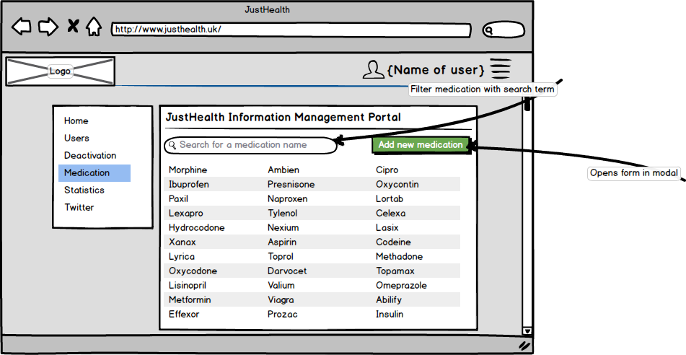This page will be to add new medication names (prescription drug names can currently only be selected from a dropdown list) this function will add the name to the list.

## 5.5 Application statistics

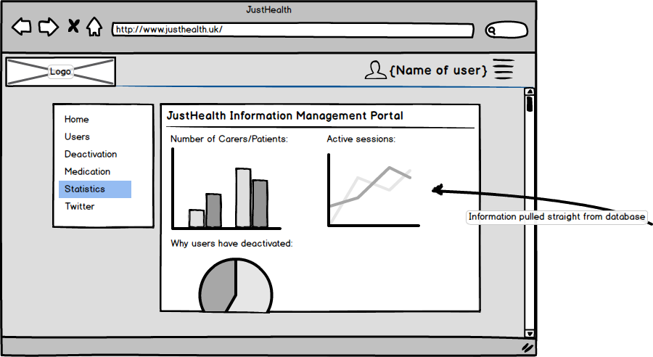This page will show statistics based on current database records and user activity

## 5.6 JustHealth Twitter